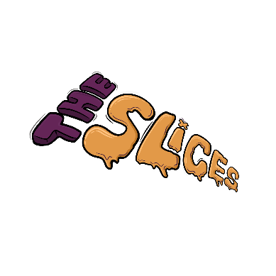

**Band Overview**

**Name:** The Slices  
**Genre:** Funk | Jazz Fusion | Groove  
**Base:** Israel

**Short Bio:**  
*The Slices* deliver an unforgettable *live experience* that’s all about energy, groove, and connection. This six-piece instrumental band transforms every stage into a full-blown *funk party*, fueled by deep rhythms, soaring solos, and relentless musical chemistry. Known for their tight interplay and explosive dynamics, *The Slices* blur the line between performance and celebration, inviting audiences to move, dance, and lose themselves in the music.

From pulsating basslines to driving percussion, funky guitars, bold brass, and vibrant keys, every note is crafted to ignite the crowd. Whether at an intimate venue or a packed festival, *The Slices* create a shared moment of joy and energy — a celebration of live music at its finest.

**For fans of:** Snarky Puppy, Vulfpeck, The Meters, Lettuce

**Live Performance Highlights**

* High-energy, groove-filled sets that transform every event into a dance party.
* Sophisticated musicianship with explosive solos and tight arrangements.
* Perfect for festivals, club shows, and intimate live music events.
* Audience interaction and improvisation create a one-of-a-kind experience at every show.



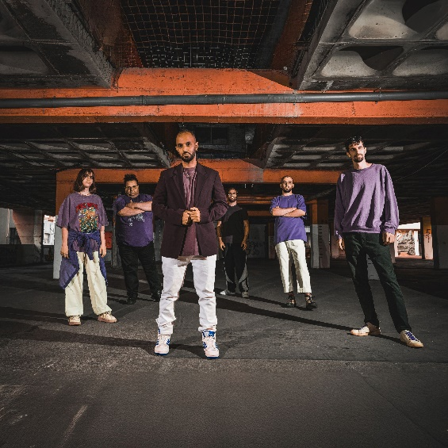

**Band Members**Trumpet: Guy Gourevich  
Saxophone: Nimrod Katz  
Guitar: Maor Vahav   
Bass: Gil Leibel   
Drums: Yoav Tene   
Keyboards: Ira Ramon   
Management & Booking: Galor Taite at Levana Records

**Media Links**

* **Live Performance Video:** <https://youtu.be/q7ZH4SJwIkA?si=iAAqka1Nun6l7Cri>
* **Music Samples:** <https://open.spotify.com/artist/1nNr6oUCnvIGJB74Dn9jwF?si=xs2yeWyERdWH2uuQ1yqQ3w>
* **Photo Gallery:** <https://drive.google.com/drive/folders/1pghOb25nMwgsvKF4rp3RiGma0z53ACwv?usp=sharing>



**Press Quotes**

“The Slices don’t just play music, they throw a party that you won’t want to end.”

“Tight grooves, incredible solos, and the kind of energy that leaves the audience begging for more.”

**Technical Requirements**

**Stage Plot:**  
A six-piece band setup requiring:

* Drum kit (microphones for kick, snare, toms, overheads)
* Bass Amp + DI
* Guitar amp + mic
* Keyboard 2 sets of stereo DI
* Saxophone DI
* Trumpet DI
* Flute DI
* 2 Additional vocal mics
* 6 monitor sends for in-ear monitors.

**Sound Check:**

* Minimum 20 minutes for setup and sound check.

**Contact Information**

* **Band Manager/Contact:** Galor Taite
* **Email:** [levanarecords@gmail.com](mailto:levanarecords@gmail.com)
* **Phone:** +972-548091916
* **Website:** [www.levanarecords.com](http://www.levanarecords.com)

**Social Media-**

* **Instagram:** <https://www.instagram.com/slicesband/>
* **Facebook:** <https://www.facebook.com/funkyslices>
* **YouTube:** <https://www.youtube.com/@theslices>

